Download and Install MySQL Sample Database
We use the classicmodels database as a MySQL sample database to help you work with MySQL quickly and effectively. The classicmodels database is a retailer of scale models of classic cars database. It contains typical business data such as customers, products, sales orders, sales order line items, etc.
We use this sample database in our MySQL tutorials to demonstrate many MySQL features from simple queries to complex stored procedures.

Download MySQL Sample Database
Download sample database via the link: MySQL Sample Database

Load Sample Database into MySQL
After uncompressing the sampledatabase.zip file into a temporary folder: C:\temp folder, you can load the sample database into MySQL database server by following:

Step 1: Connect to the MySQL server using the mysql client program.
The mysql program is located in the bin directory of the MySQL installation folder.


Step 2: Use the source command to load data into the MySQL Server:

Step 3: Use the SHOW DATABASES command to list all databases in the current server:
The output will look like the following that includes the newly created classicmodels database:
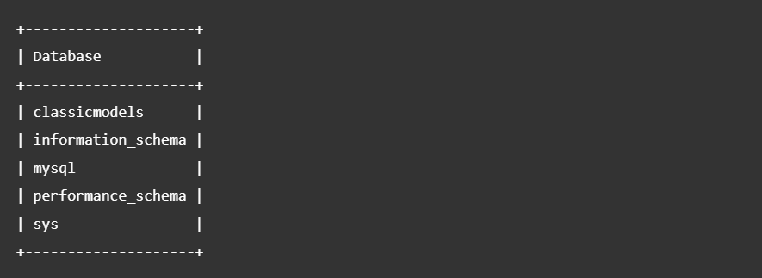

Step 4: Test it by using the following SQL statements:

Basically, those statements switch the current database to classicmodels and query data from the customers table. If you see the customer data returned, you have successfully imported the sample database into the MySQL database server.

MySQL Sample Database Schema
The MySQL sample database schema consists of the following tables:
- Customers: stores customer’s data.
- Products: stores a list of scale model cars.
- ProductLines: stores a list of product line categories.
- Orders: stores sales orders placed by customers.
- OrderDetails: stores sales order line items for each sales order.
- Payments: stores payments made by customers based on their accounts.
- Employees: stores all employee info and the organization structure (who reports to whom)
- Offices: stores sales office data.
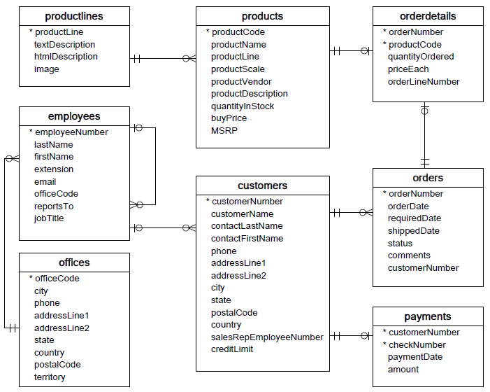
You can download the MySQL sample database ER-diagram in PDF format via the following link.
Download MySQL Sample Database Diagram PDF A4

